## Working with Visio 2013 and Visio Services

**Lab Time**: 60 minutes

**Lab Folder**: C:\Student\Modules\VisioServices\Lab

**Lab Overview**: In this module you will learn how to work with Visio 2013 and Visio Services. You will build a Visio diagram, connect external data to shapes, publish the Visio file to SharePoint, and work with the file through Visio Services.

### Exercise 1: Visio Diagram Linked to WingtipSales Excel Data

In this exercise you will create a regional diagram, link the shapes to the WingtipSales Excel data, insert fields on the shapes, and then publish the file to SharePoint.

#### Create New Visio Diagram

1. From the desktop, launch **Visio 2013** if it is not already open.
2. Start with a **Blank Drawing**.
3. Select desired units and then click **Create**.

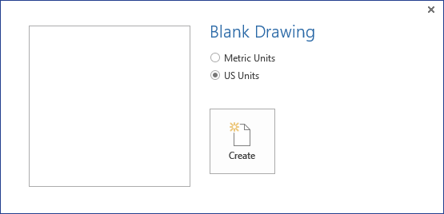

#### Import WingtipSales Excel Data

1. In Visio 2013 from the DATA tab, click **Link Data to Shapes**.

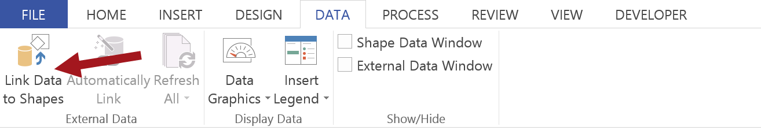

1. Choose **Microsoft Excel workbook** and then click **Next**.

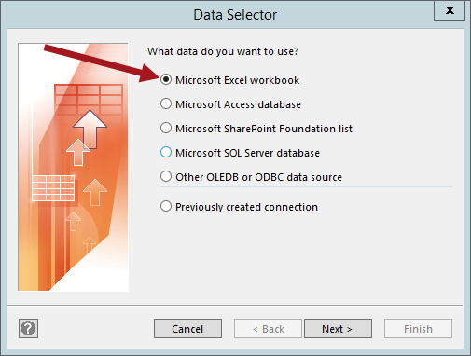

1. In the **Data Selector** dialog, click on **Browse**.

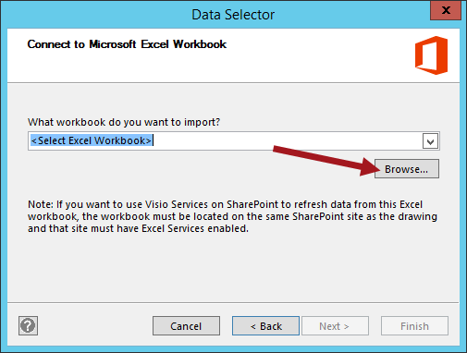

1. Browse to **C:\Student\Modules\ExcelServices\Lab\Solution**. Select the **WingtipSalesModel.xlsx** file, click **Open** and then click **Next**.

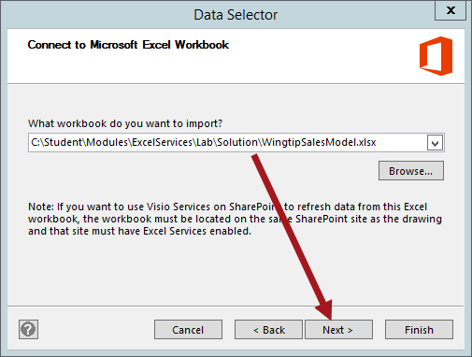

1. Choose **‘Sales by Customer Geography$’** in the **What worksheet or range do you want to use?** and then click **Next**.

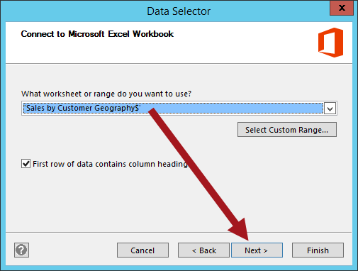

1. In the **Connect to data** dialog, leave the default settings and click **Next**.

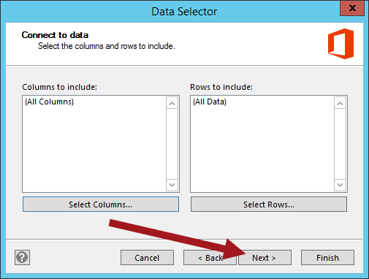

1. In the **Configure Refresh Unique Identifier** dialog, ensure **Row Labels** is selected, click **Next** and then click **Finish**.

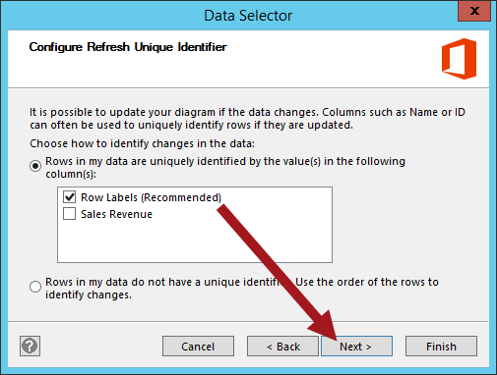

1. The **Sales by Customer Geography** data should now be linked and displayed in the **External** **Data** window.

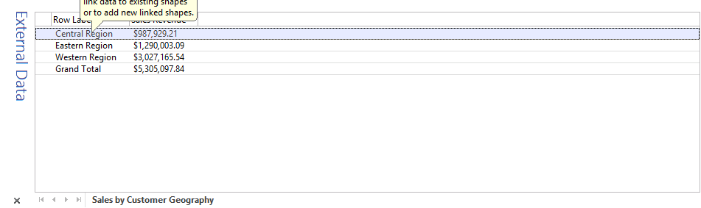

1. Now open the Wingtip stencil.
   1. In the **Shapes** panel, click on **More Shapes > Open Stencil**

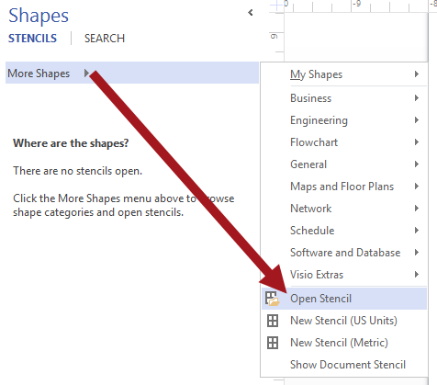

* 1. Browse to **C:\Student\Modules\VisioServices\Lab** then click on the **Wingtip.vssx** file and click **Open**.

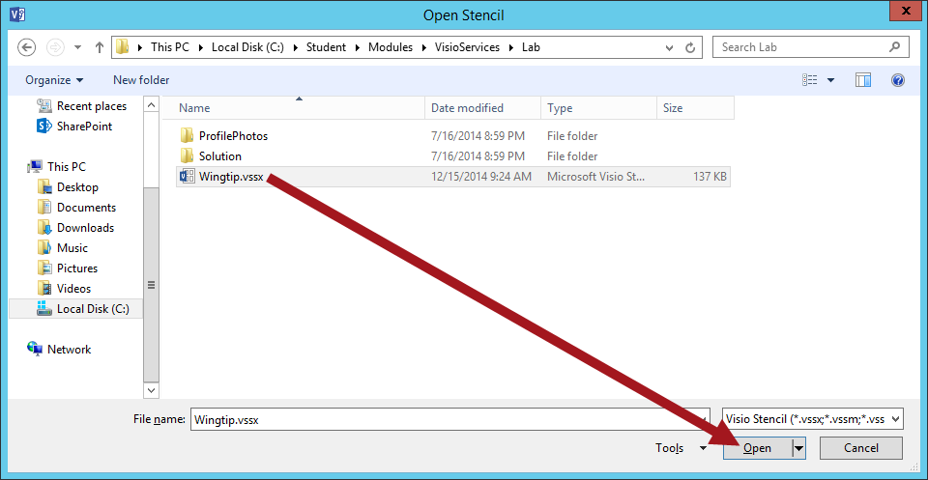

* 1. The **Eastern**, **Western**, and **Central** shapes should now be displayed in the Shapes panel.

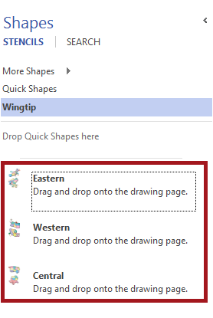

1. Drag each of the regions onto the page.

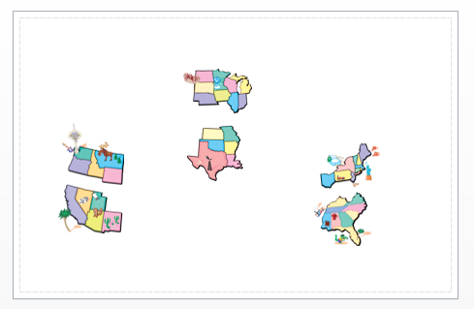

#### Link the Data to the Region Image Shapes

1. Now link the data to the appropriate region shape.
   1. From the **External Data** window, click on the **Eastern Region** row. Hold down the mouse button, drag the row to the Eastern shape and then release the mouse. Continue until all regions are linked.

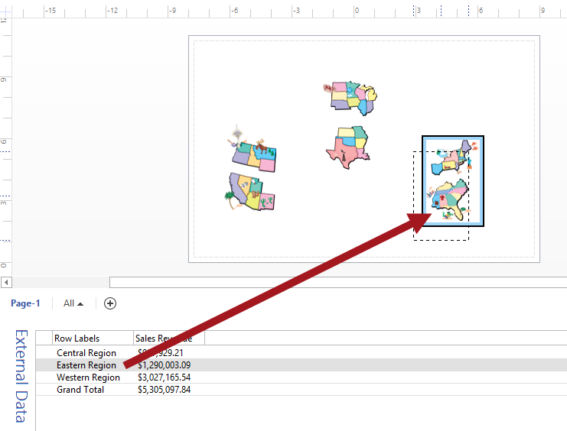

1. Next update the fields for the shapes.
   1. **Double-click** on the Western region shape and then right-click and select **Insert Field** from the drop-down menu.

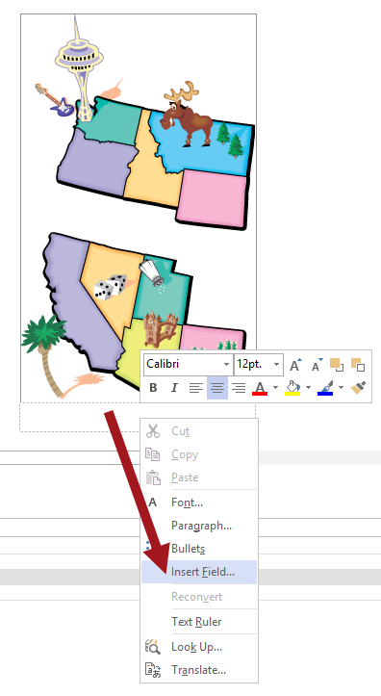

* 1. Choose **Shape Data > Row Labels** and then click **OK**.

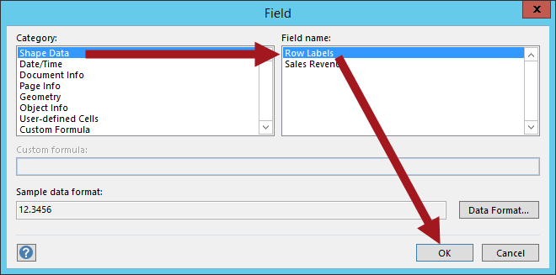

* 1. The field should now be displayed below the shape image. Now press the **Enter** key (on keyboard) to go to the next line.

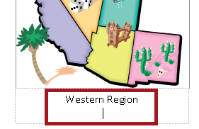

* 1. Now add the Sales Revenue field. **Right-click** and select **Insert Field**. Choose **Shape Data > Sales Revenue** and click **OK**.

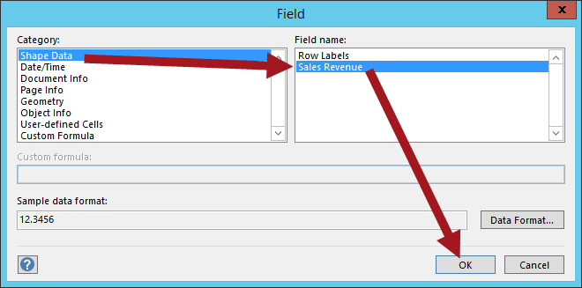

* 1. Repeat the steps for the remaining regions until complete.

1. The region shapes should look similar to the figure below.

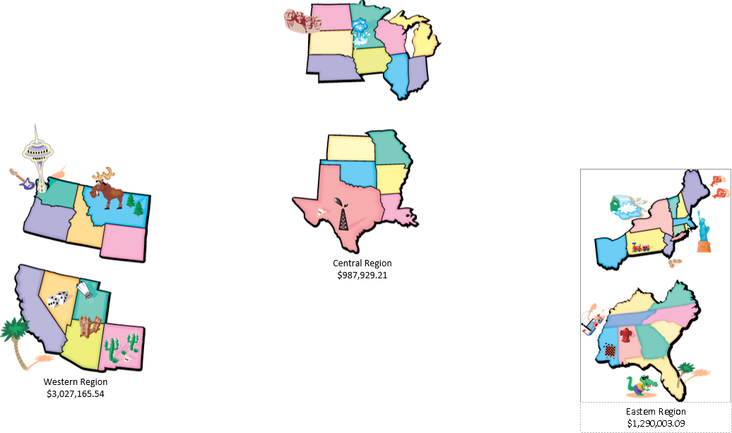

1. Resize the images to the desired size and reposition of needed. Once complete, save the file locally and name it **SalesbyRegion.vsdx**.

#### Publish Diagram to SharePoint

1. Navigate in the browser back to your BI Center site: [**http://intranet.wingtip.com/sites/bicenter**](http://intranet.wingtip.com/sites/bicenter)
2. Upload Visio file to the Documents library.
   1. Navigate to the Documents library by going to the **Site Contents** and then click on the **Documents** tile.
   2. Click on the **+ new document** link.

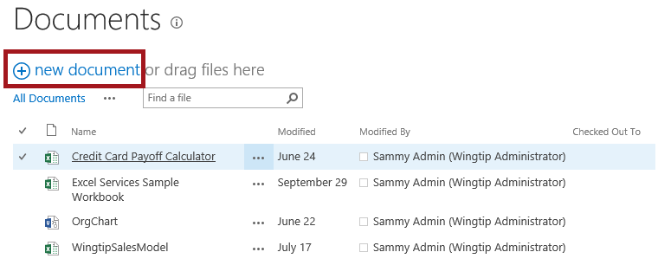

* 1. Browse to the locally saved **SalesbyRegion.vsdx** file and then click **OK**.

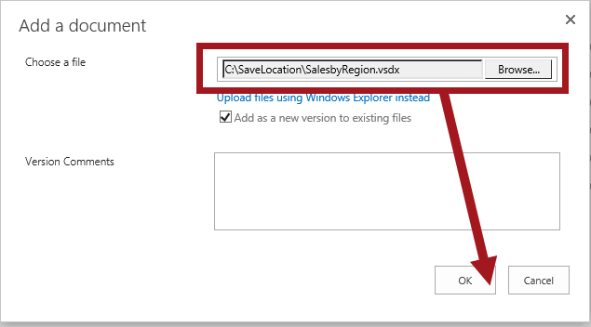

* 1. Click on the newly uploaded Visio file to view the file in the browser through Visio Services.

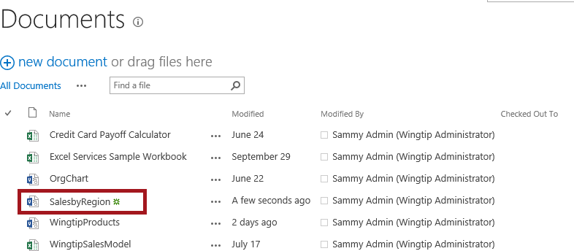

1. The Visio file is now displayed in the browser through Visio Services.

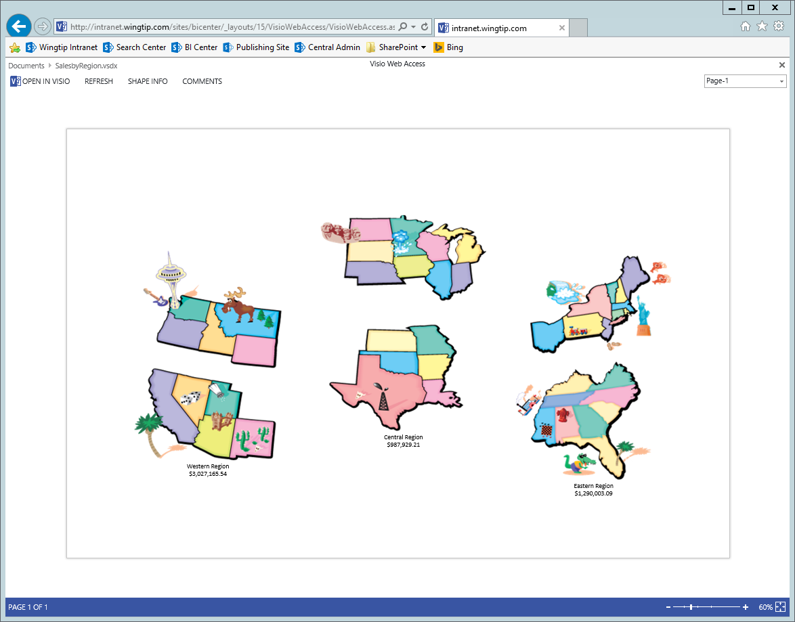

1. This exercise is now complete.

#### Setup Connection

1. Navigate to the BI Center site home page: [**http://intranet.wingtip.com/sites/bicenter**](http://intranet.wingtip.com/sites/bicenter)
2. Go into **Edit** mode for the page.
3. Add the Visio Web Part
   1. In the zone where you want to place the **Visio Web Access Web Part**, click **Add a Web Part**.
   2. In the **Categories** list, click **Business Data**.
   3. In the Web Parts list, click **Visio Web Access** and then click **Add**.

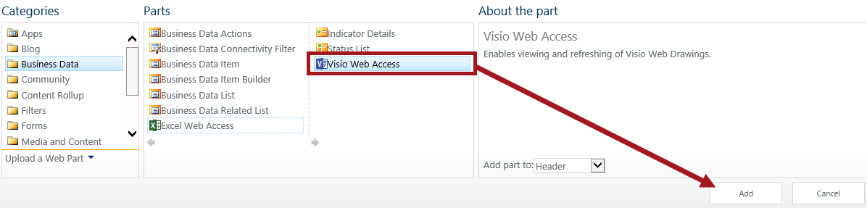

1. Click the arrow next to Content Editor Web Part Menu, and then click Edit Web Part.
2. Type the URL of the .js file you want to open, and then click OK.
3. Add all the Web Parts you want to connect to the page.
4. In the corner of the **Visio Web Access Web Part**, click the arrow to open the Visio Web Access Web Part Menu, and then click **Edit Web Part**.
5. In **Edit** Mode, click the arrow to open the Visio Web Access Web Part Menu again, Point to **Connections** and then click the connection option you want.
6. A Visio Web Access web part that is connected to another web part. In this example, the Visio Web Access web part highlights shapes based upon selections made in a SharePoint list titled “Visio Web Access list.”
7. Choose which parameter in the Web drawing corresponds to which parameter in the other Web Part.

You can make only one mapping between parameters. If you want to map multiple parameters, use SharePoint Designer to create the mappings.

### Exercise 2: Visio Diagram Linked to SharePoint Products List

In this exercise you will connect a Visio diagram to the Products SharePoint list stored in Wingtip Intranet site. You will import the product images, link the data to the images, modify the Shape Data, and then save the diagram to SharePoint.

#### Connect Visio Diagram to the Products List

1. From the desktop, launch **Visio 2013**.
2. Start with a **Blank Drawing**.

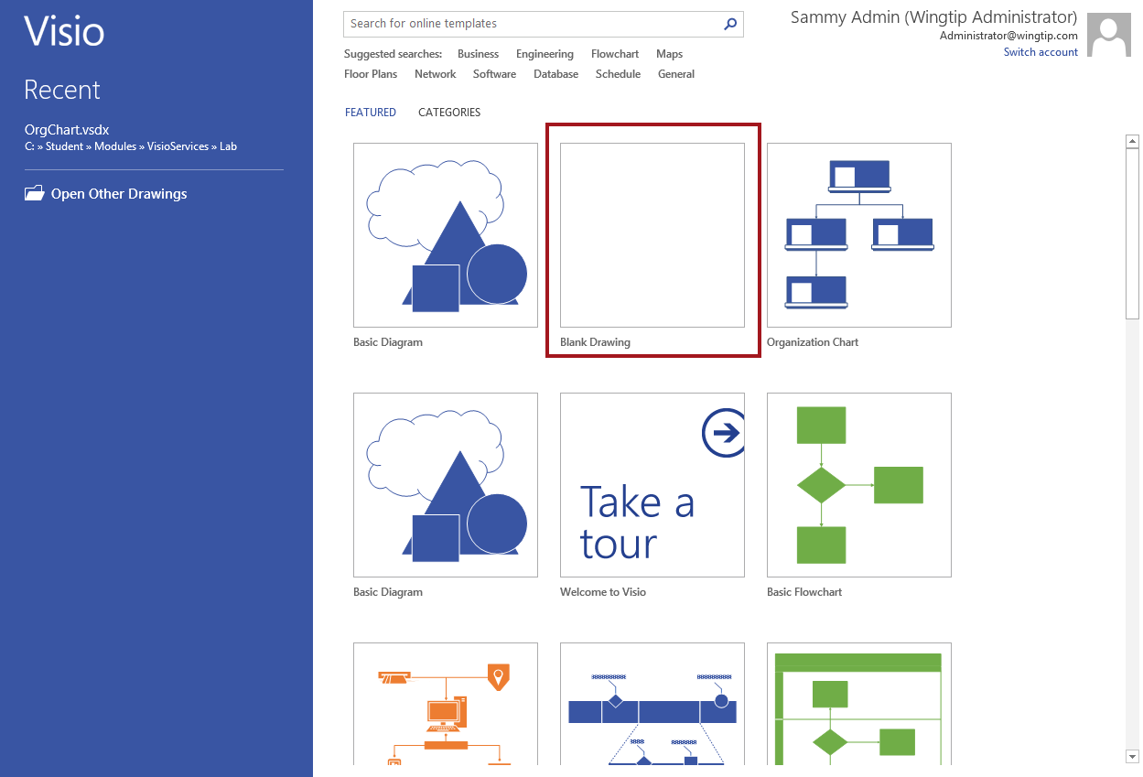

1. Select desired units and then click **Create**.



1. In **Visio 2013** from the **DATA** tab, click **Link Data to Shape**s.



1. Choose **Microsoft SharePoint Foundation list** and then click **Next**.

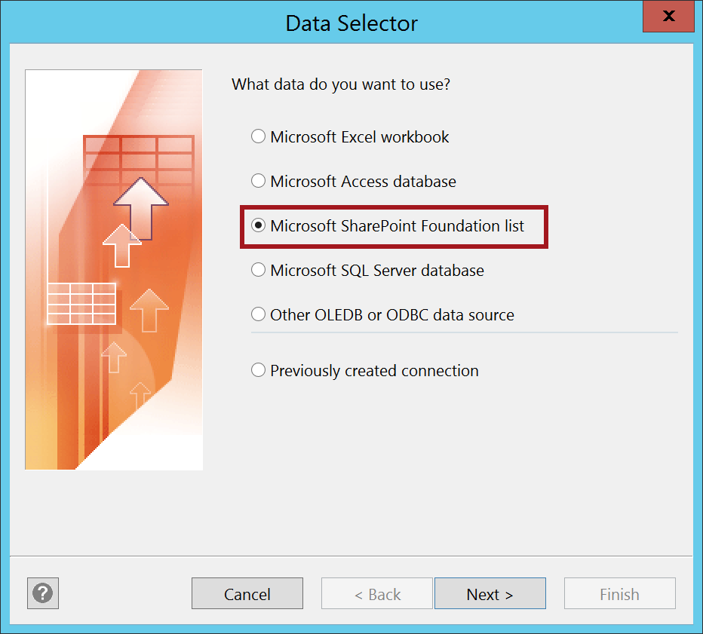

1. On the **Select a site** dialog, type the <http://intranet.wingtip.com> for the SharePoint site and then click **Next**.

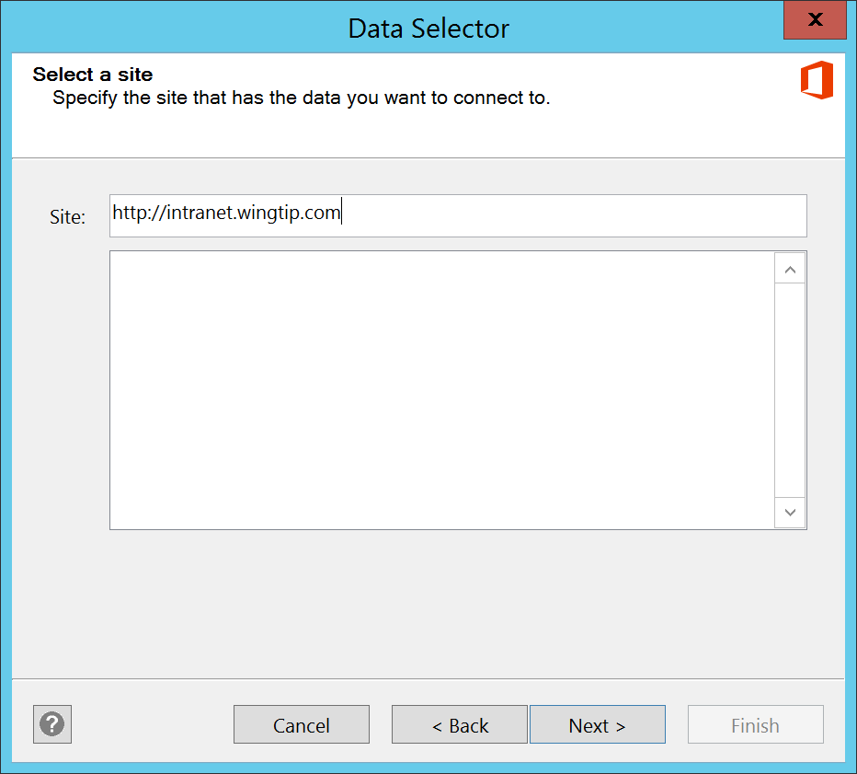

1. On the **Select a list** dialog, select **Products** from the **Lists** list (leave Link to a list selected) then click **Next** and click **Finished**.

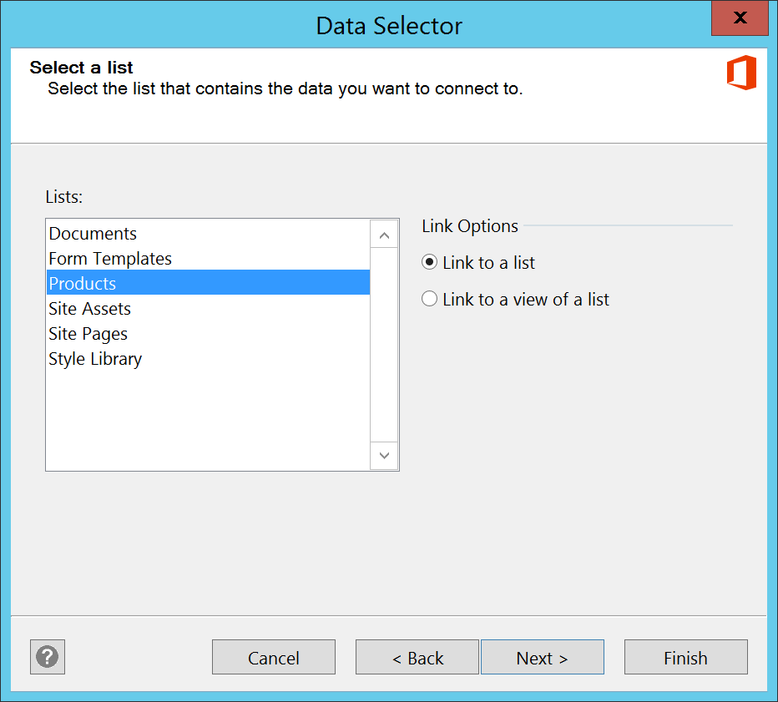

1. The Visio diagram is now connected to the Products SharePoint list.

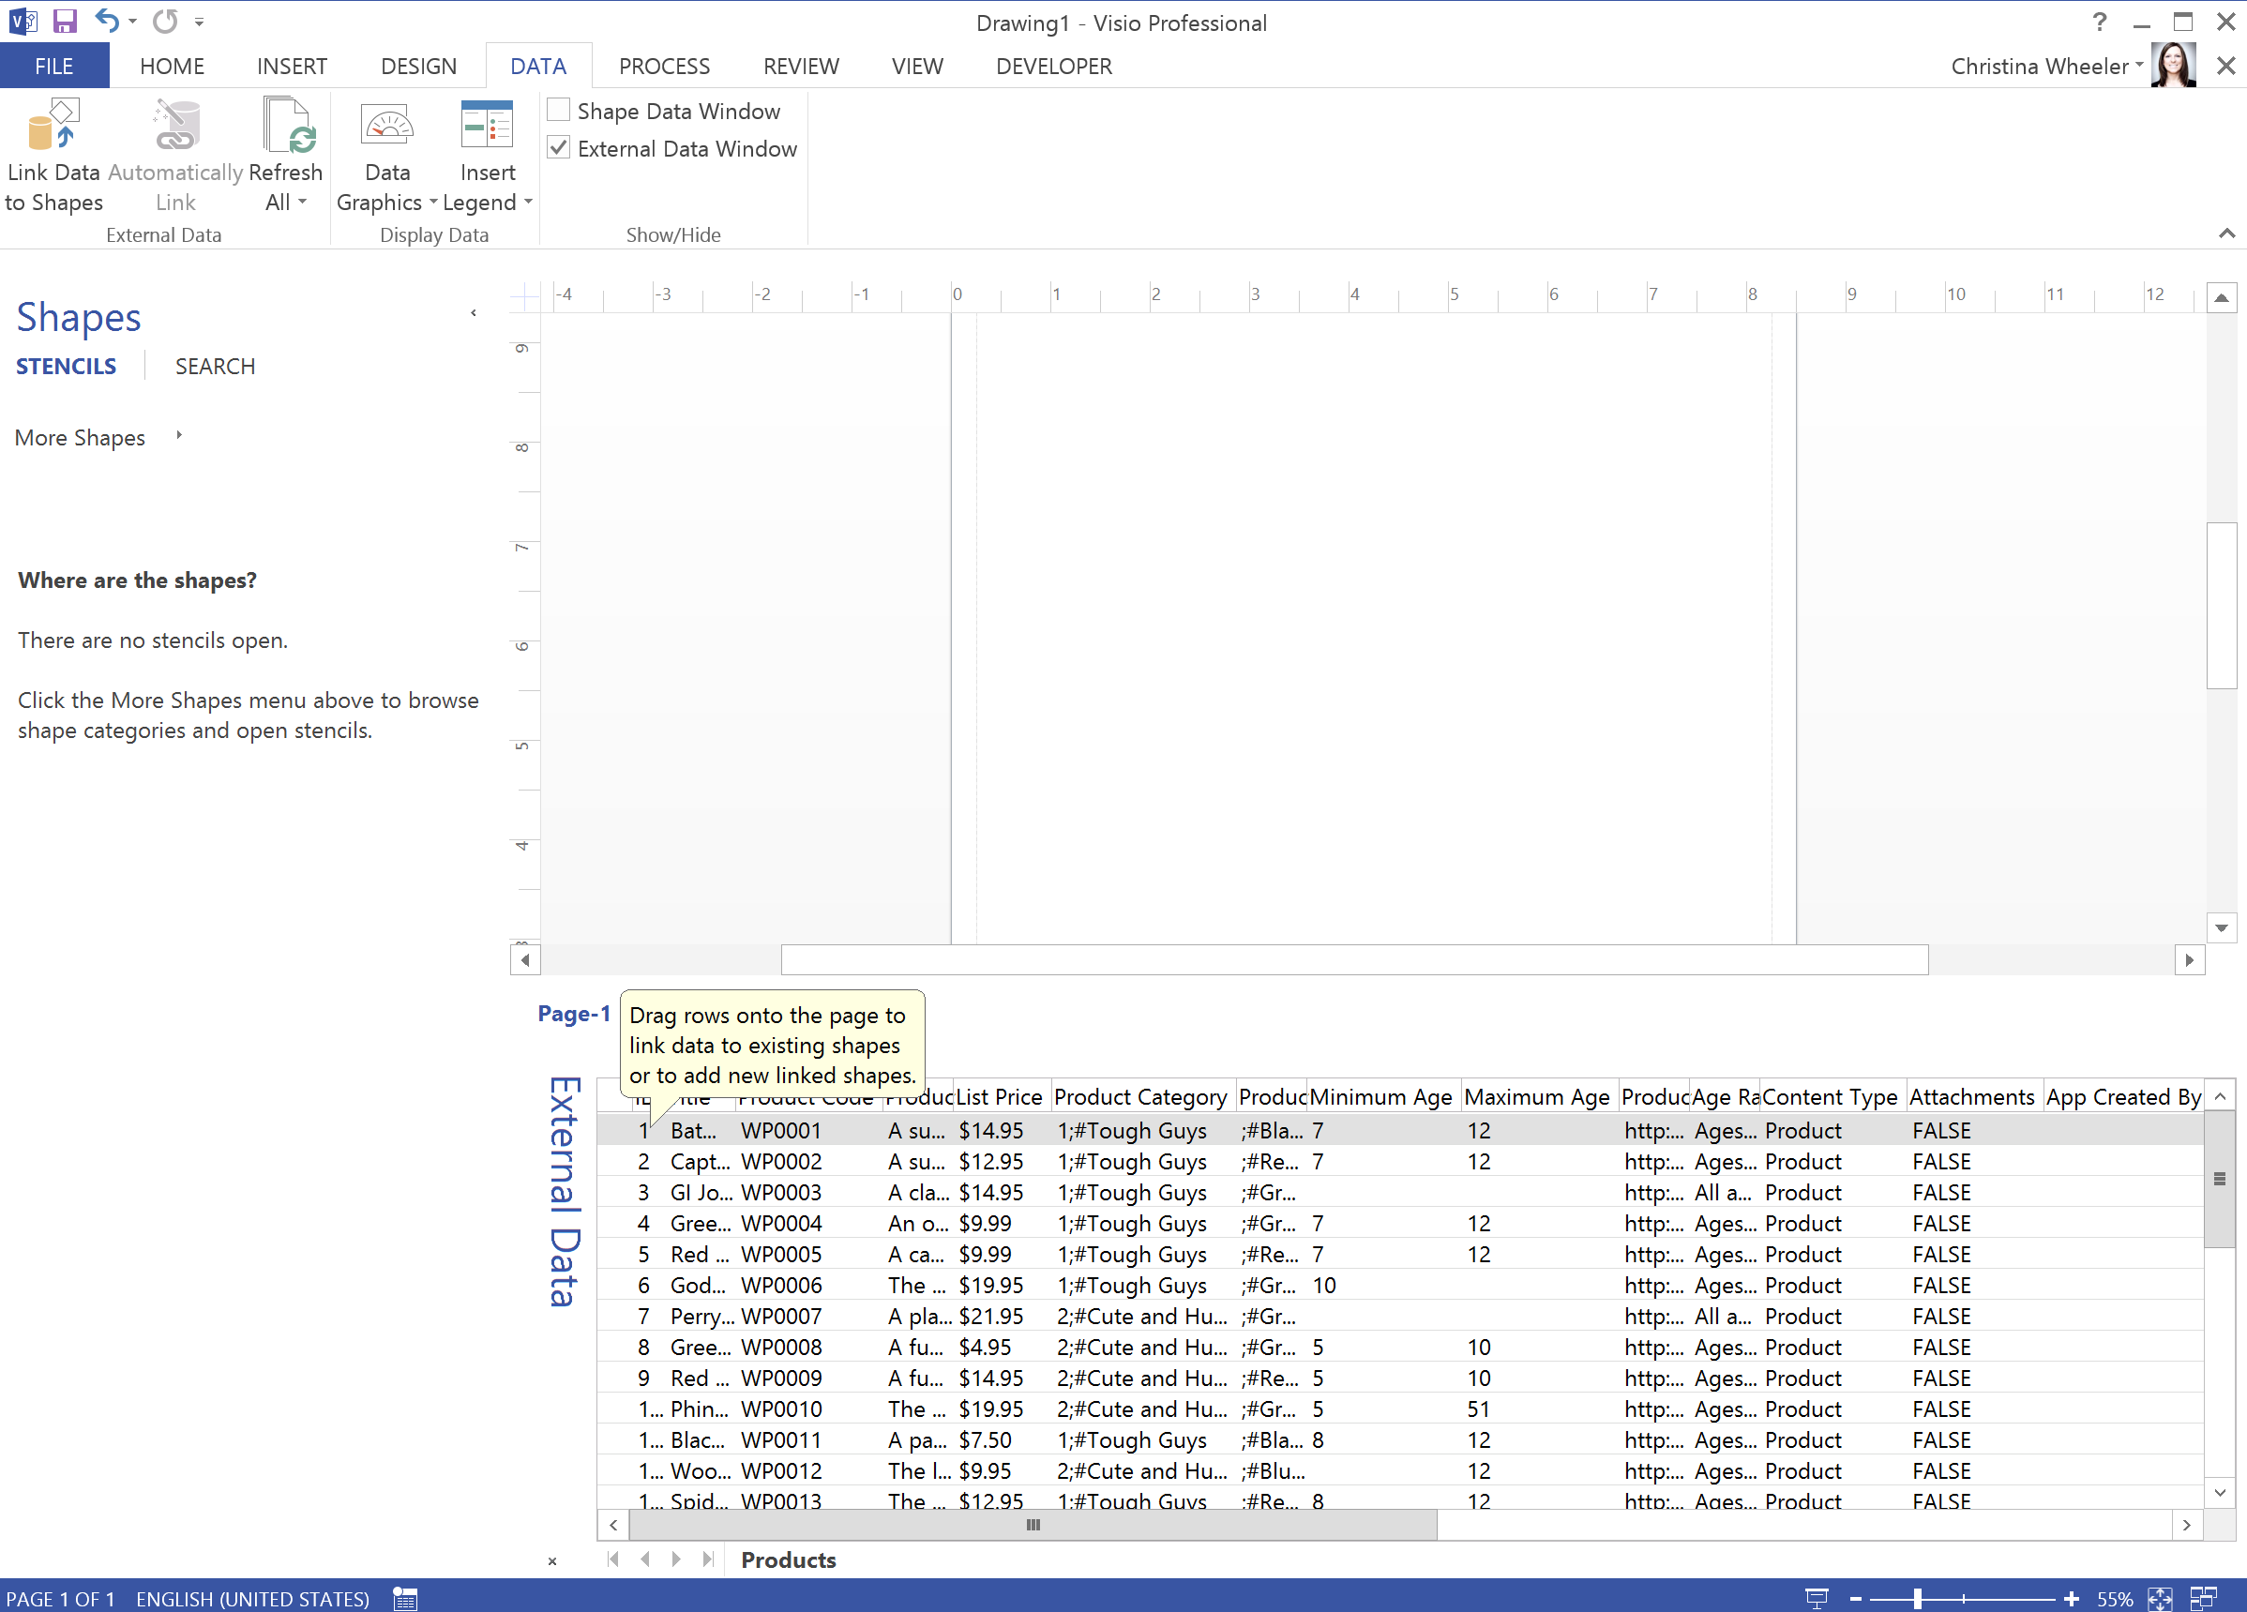

The data in the **External Data** window is a snapshot of your source data at the time of import. You can refresh this data to match changes in your source data (click **Refresh All** on the **Data** tab), but Visio doesn’t send changes in the diagram back to the data source.

To hide the **External Data** window, on the **Data** tab in the **Show/Hide** group, clear the **External Data Window** check box.

1. **Save** your file locally and name it **WingtipProducts.vsdx**.

#### Create Product Category Pages

1. Create 3 different pages called Action Figures, Arts & Crafts, and Remote Control.
   1. Rename the **Page-1** page to **Action Figures**.
   2. Right-click on Page-1 and click on **Rename**.

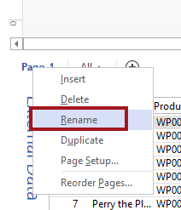

* 1. Add a new page by clicking on the + sign.

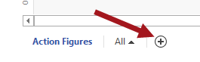

* 1. Rename **Page-2** to **Arts & Crafts**. Repeat the steps to make another sheet called **Remote Control**. You should now have 3 different pages as shown in the figure below.



#### Add Product Images to Visio Diagram

1. Make the Action Figures page active by clicking on **Action Figures**.
2. Now add all the action figures images to the Action Figures canvas by following the steps below:
   1. From the **INSERT** tab, click on the **Online Pictures** ribbon button.

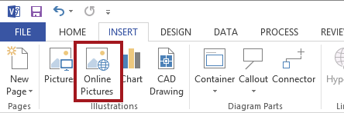

* 1. From the Insert Pictures dialog, click on **From SharePoint**.

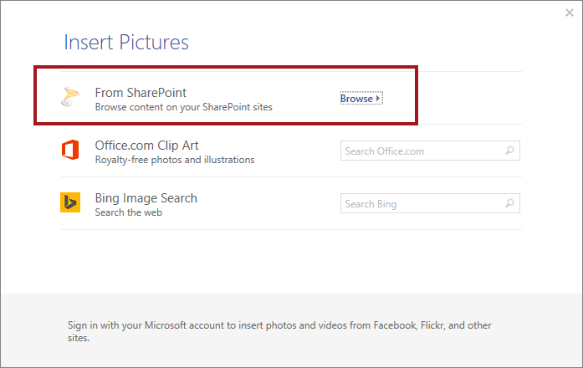

* 1. Type the web address: <http://intranet.wingtip.com> and then click the right arrow located next to the address bar.

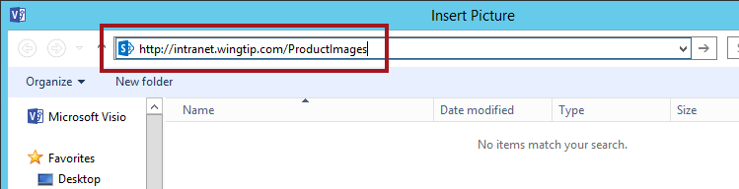

* 1. Double-click on **Product Images**.

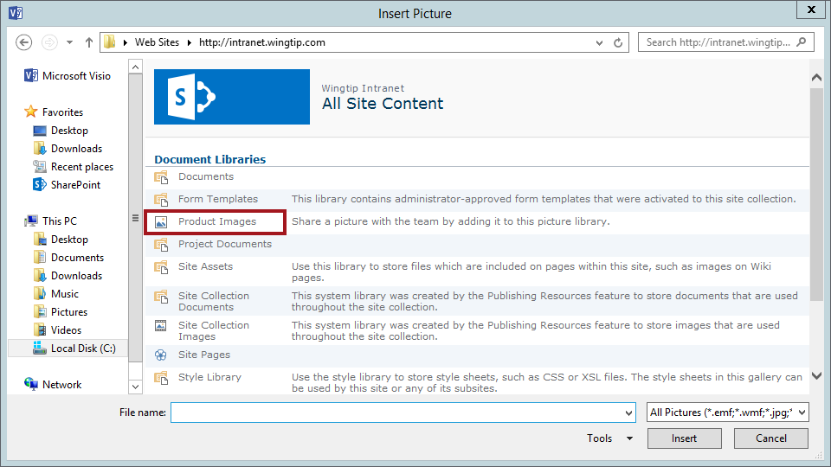

* 1. Select images **WP0001.jpg through WP0014.jpg** and then click **Insert**.

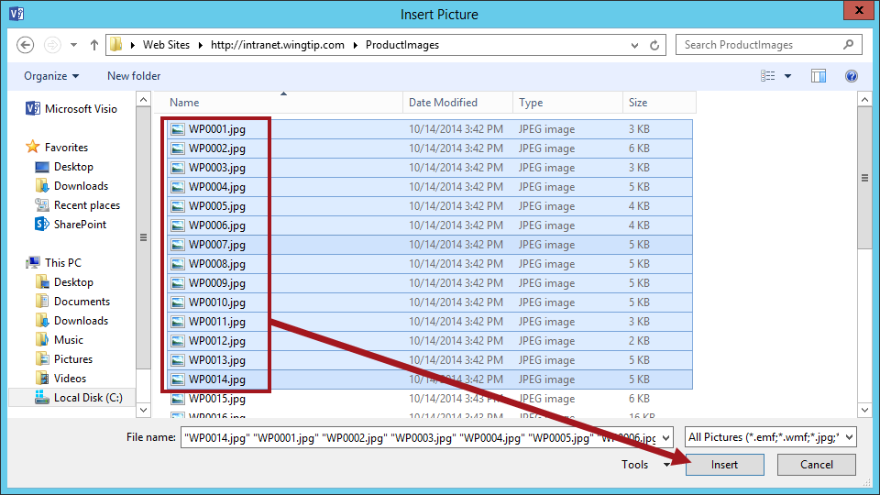

* 1. The images will be added to the canvas on top of each other.

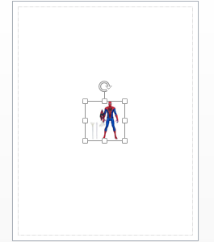

* 1. Arrange the product images on the canvas by selecting the top image and dragging to the desired location. Continue until the product images are arranged similar to the figure below. Use the align and position tools in the ribbon to adjust the images accordingly.



You can also add the images using “Open in Explorer” from the Product Images library and then selecting the images from the Explorer Window and dragging them to the canvas.

1. Now add images to the Arts & Crafts page.
   1. Click on the **Arts & Crafts** page and repeat the steps to add images but this time add the images **WP0015.jpg through WP0019.jpg**.
   2. Rearrange the images similar to the figure below.

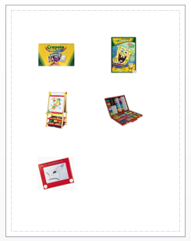

1. Now add the remaining images to the Remote Control page.
   1. Click on the **Remote Control** page and repeat the steps to add images but this time add the images **WP0020.jpg through WP0032.jpg**.
   2. Rearrange the images similar to the figure below.

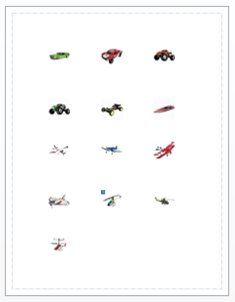

#### Link the Data to the Product Images Shapes

1. In the next steps you will link the external data to the appropriate product image.
2. Start with the Action Figures page.
   1. From the **External Data** window, click on the **Batman Action Figure** row. Hold down the mouse button, drag the row to the Batman figure and then release the mouse.

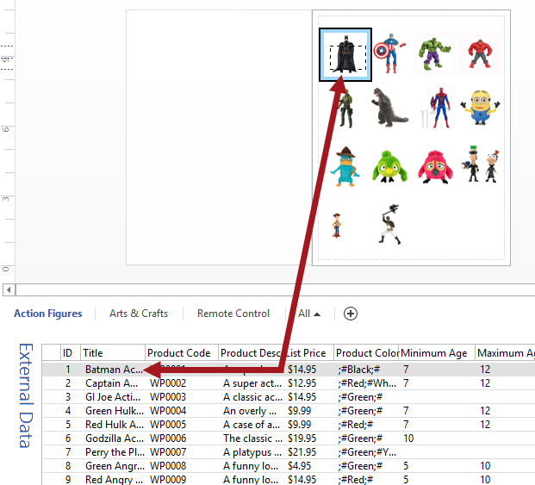

* 1. The first row should now be connected to the Batman figure. The link icon will now show up on the row indicating that the Batman Action Figure row is now linked to a shape in the diagram.



1. Repeat the steps to link up the data to the corresponding image. Do this for all 3 pages. Once complete, continue to the next step.

#### Update the Shape Data

1. Now activate the Shape Window.
   1. From the **DATA** tab, in the *Show/Hide* group click on **Shape Data Window**.

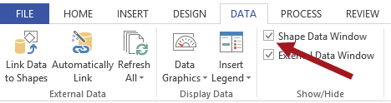

* 1. The Shape Window should now be appearing on the screen.

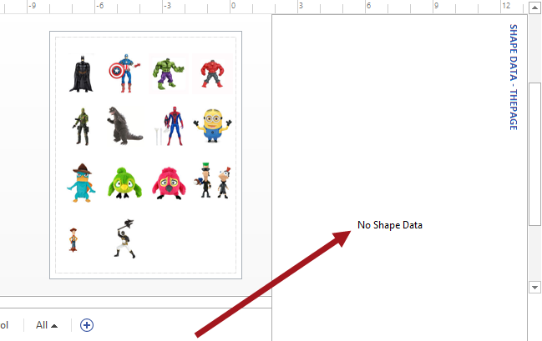

1. Click on any one of the product images. The Shape Data window will now display the linked data for the selected image.

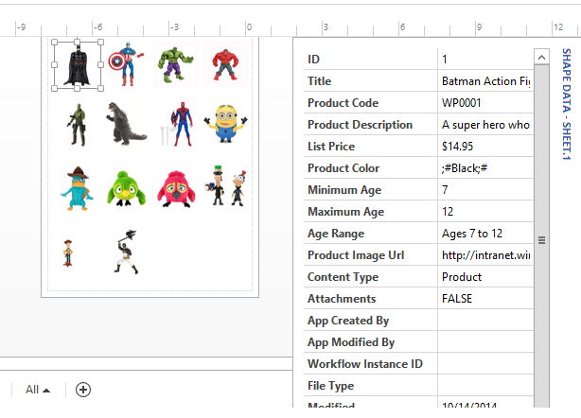

The data in the Shape Data window will be the same data that will show up when viewing the diagram through Visio Services.

1. To update the Shape Data fields, follow the steps below.
   1. Start with the **Action Figures** page. Select all the product images (Ctrl + A) then right-click. From the drop-down list select **Data** and then select **Define Shape Data**.

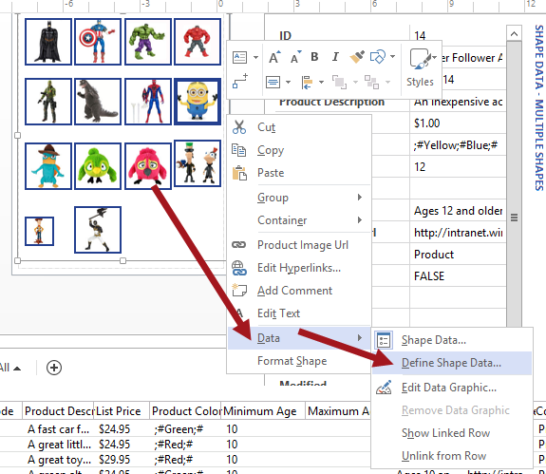

* 1. The **Define Shape Data** dialog will appear displaying the property of the first field ID.

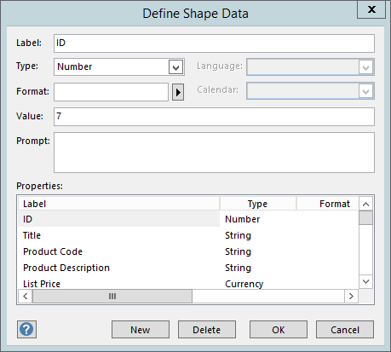

* 1. From here you can rename, add, and remove desired data columns. Delete **ID**, **Product** **Color**, **Content** **Type**, **Attachments**, **App** **Created** **By**, **App** **Modified** **By**, **Workflow** **Instance** **ID**, **File** **Type**, **Modified**, **Created**, **Created** **By**, **Modified** **By**, **URL** **Path**, **Path**, **Item** **Type**, and **Encoded** **Absolute** **URL**
  2. Click **OK**. The fields remaining should be the similar to the figure below.

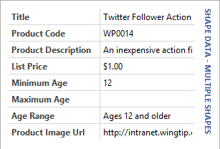

1. Repeat the same steps for the **Arts & Crafts** page and the **Remote Control** page.
2. When complete, **save** the file and close Visio 2013 then continue to the next steps.

#### Publish Diagram to SharePoint

1. Navigate in the browser back to your BI Center site: [**http://intranet.wingtip.com/sites/bicenter**](http://intranet.wingtip.com/sites/bicenter)
2. Upload Visio file to the Documents library.
   1. Navigate to the Documents library by going to the **Site Contents** and then click on the **Documents** tile.
   2. Click on the **+ new document** link.



* 1. Browse to the locally saved Visio file and then click **OK**.

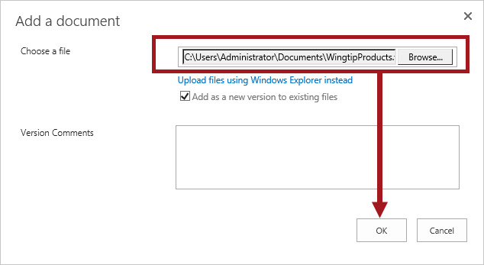

* 1. Click on the newly uploaded Visio file to view the file in the browser through Visio Services.

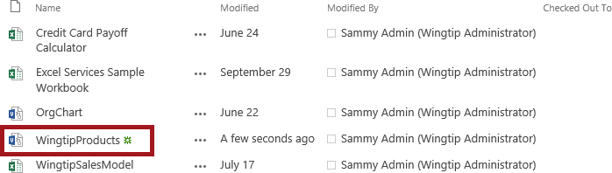

* 1. The Visio file is now displayed in the browser through Visio Services.

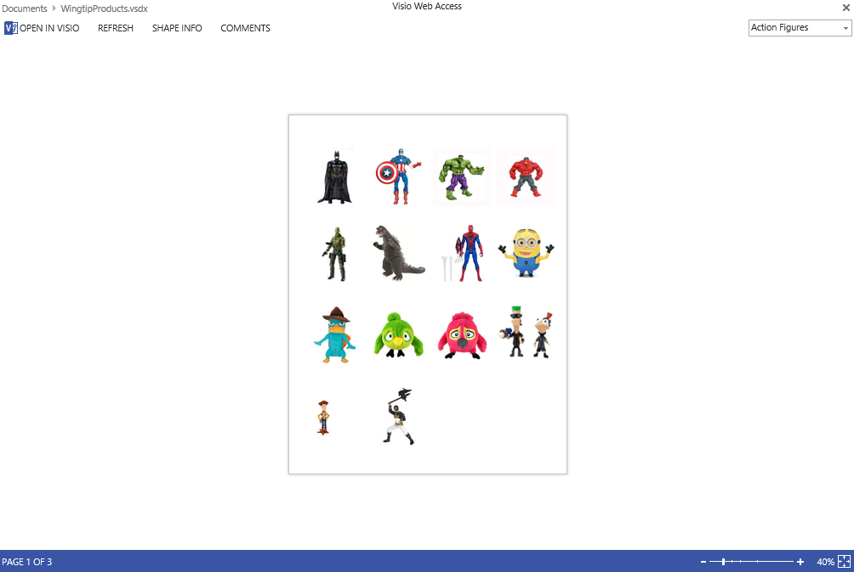

1. Now navigate between the different pages.
   1. In the drop-down list in the upper right-hand corner is the different pages that were created in Visio. Select **Arts & Crafts** in the drop-down list and notice the page changes.



* 1. The **Arts & Crafts** page should now be displayed similar to the figure below.

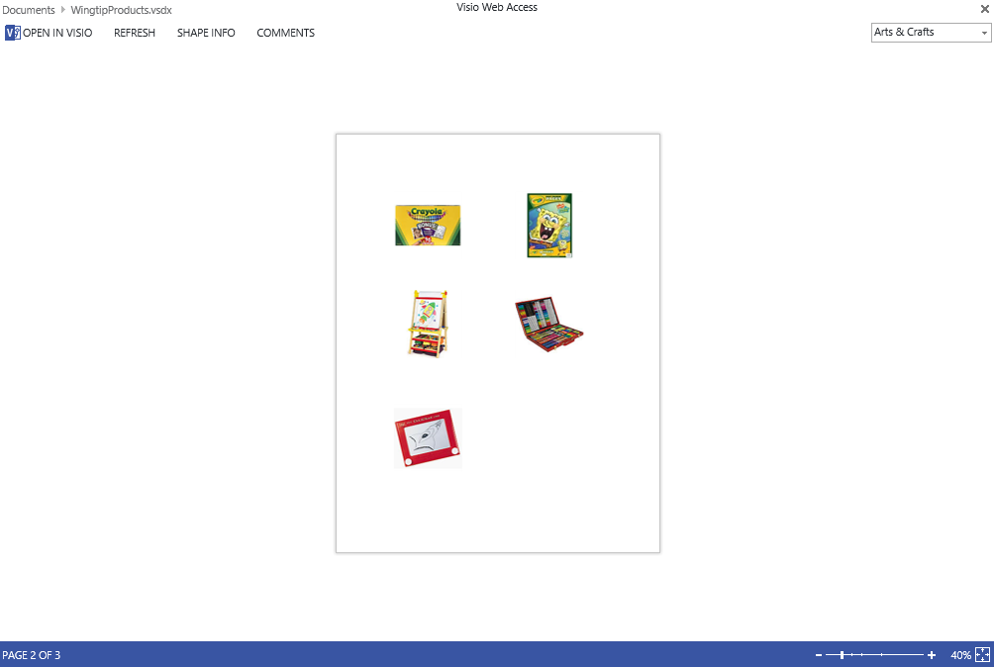

* 1. You can resize the page by using the controls located in the lower right-hand corner.

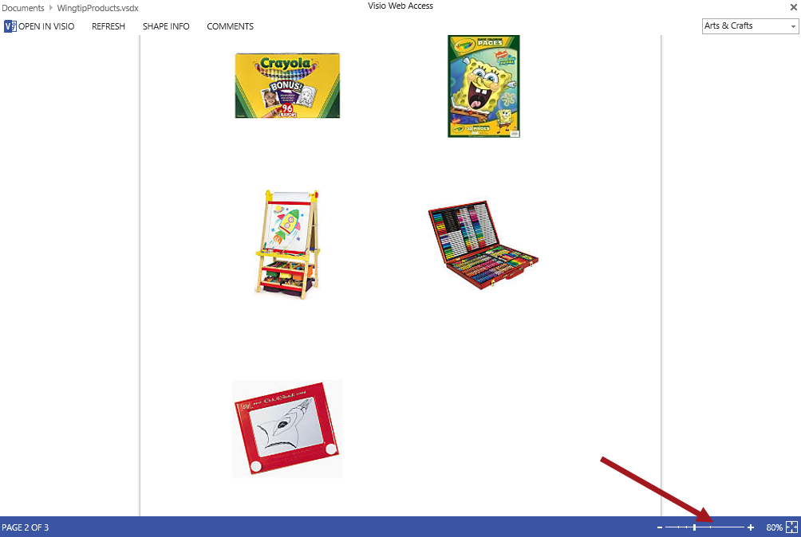

1. Now active the Shape Info web control.
   1. In the upper left-hand corner click on **SHAPE INFO**.



* 1. The SHAPE INFO module window should now be displayed on the page.



* 1. Click on a product image and notice the SHAPE INFO updates with information about the selected product image. Resize the SHAPE INFO module window.

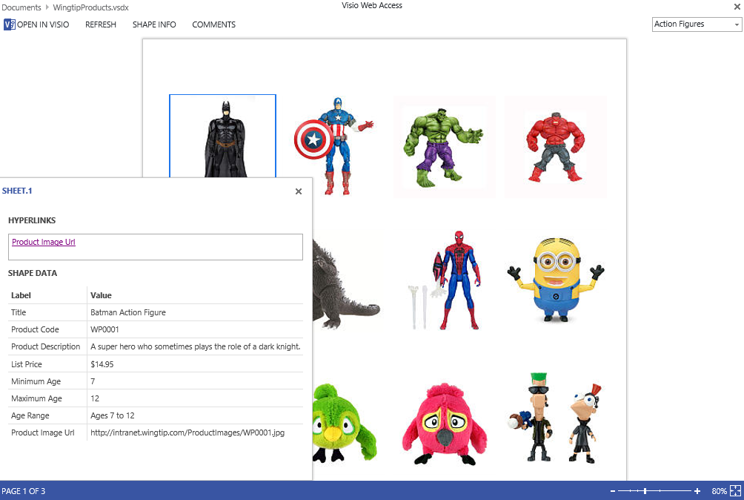

* 1. Click on different product images to see the data update in the SHAPE INFO module window.

1. This exercise is now complete.

### Exercise 3: Create a Visio Organizational Chart

In this exercise you will learn how to create an Organization Chart by importing Active Directory data stored in an Excel file and profiles photos stored in the local file system.

#### Create the Organizational Chart in Visio

1. From the desktop, launch **Visio 2013** if it is not already open.
2. From Visio, create a new file and click on **Organization** **Chart**.

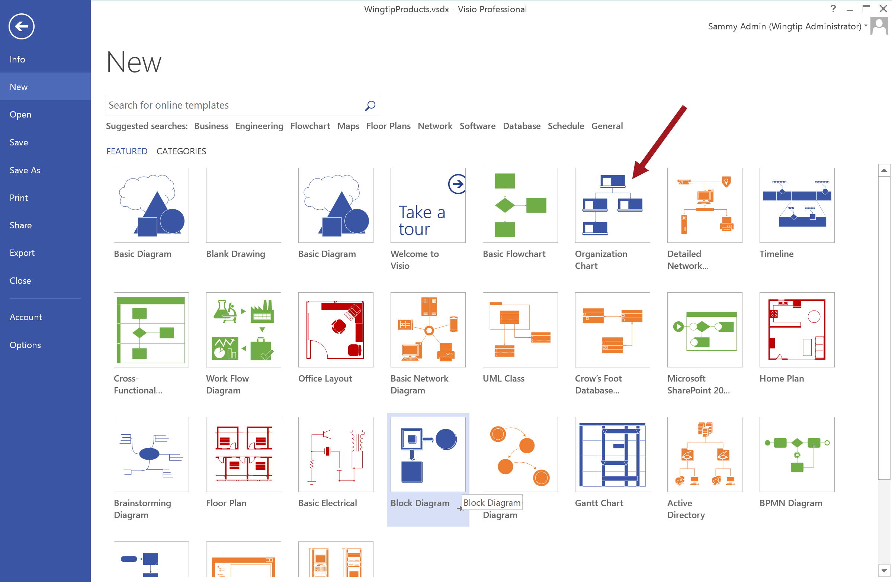

1. Select desired unit and then click **Create**.

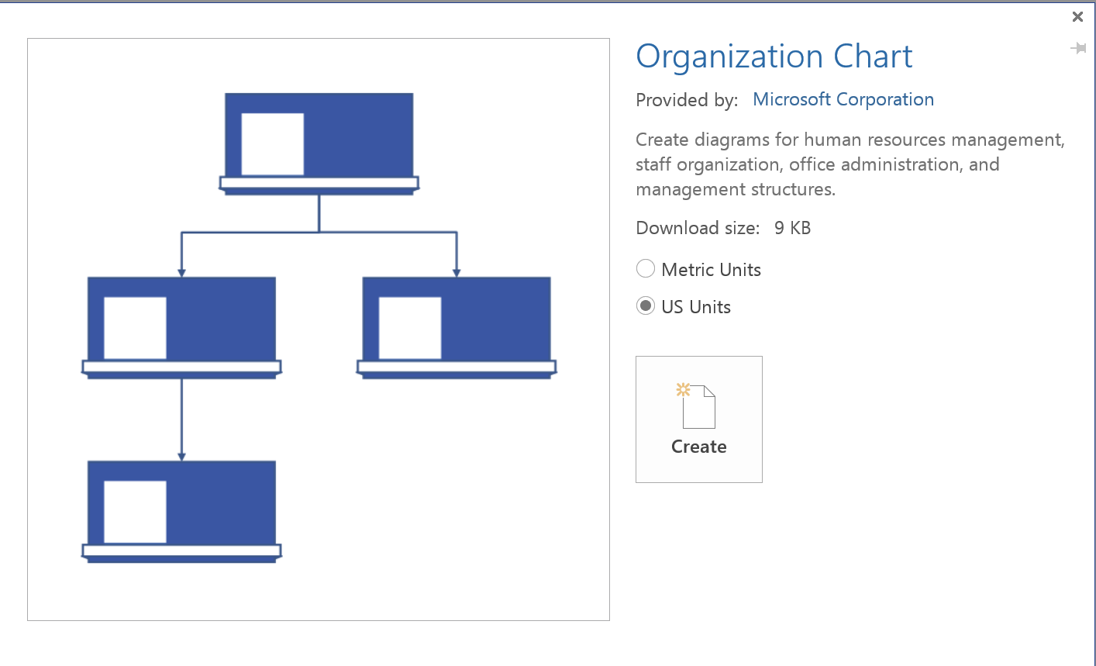

1. From the Organization Chart Wizard, select **Information that’s already stored in a file or a database** and then click **Next**.

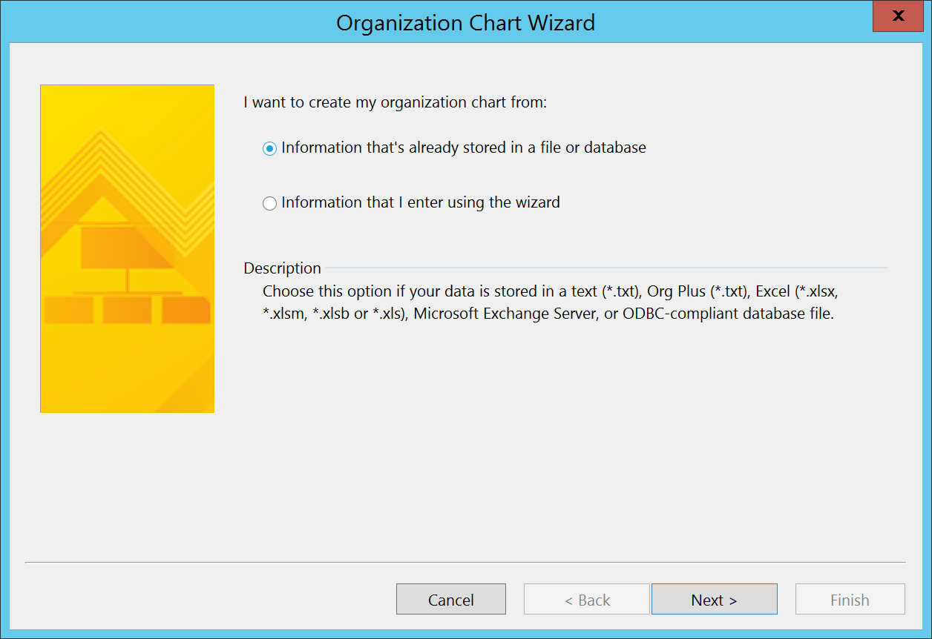

1. For the **My organization information is stored in** value select **A text, Org Plus (*.txt), or Excel file** and then click **Next**.

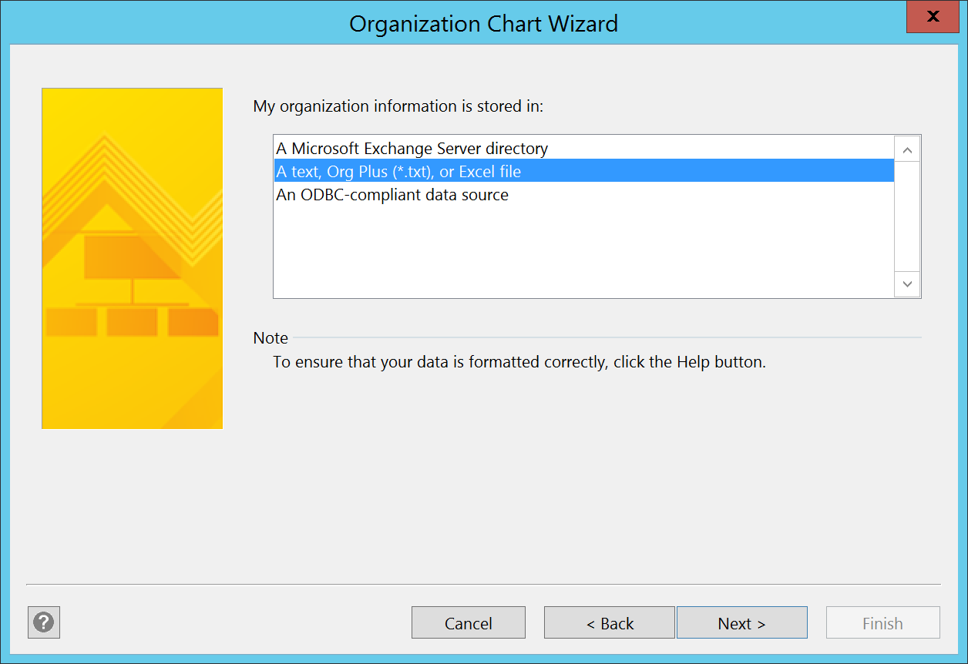

1. Click **Browse…** then navigate to **C:\Student\Modules\VisioServices\Lab\WingtipUsers.xlsx**. Select the file and then click **Open**.

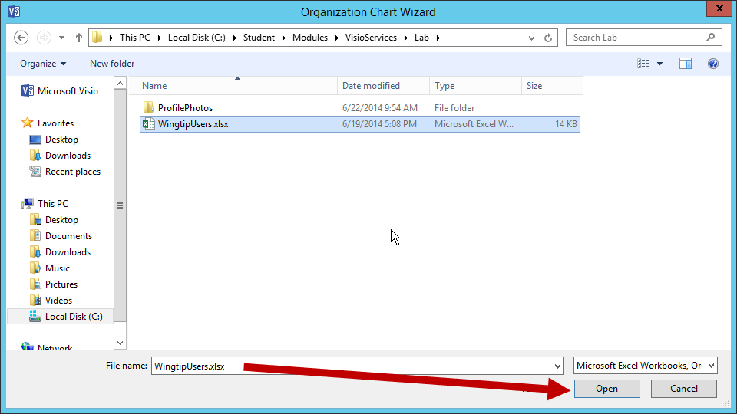

1. Now click **Next**.

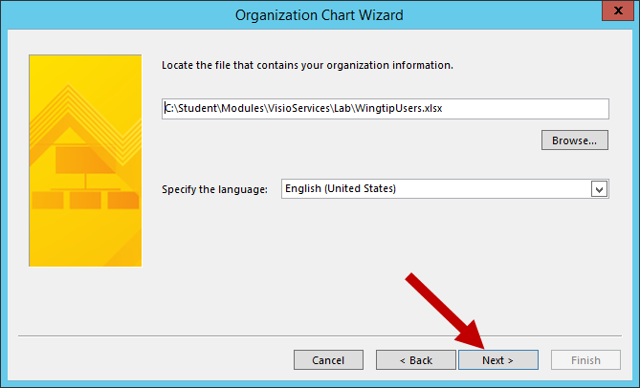

1. Ensure the following is set and then click **Next**.
   1. **Name** = name
   2. **Reports to** = manager

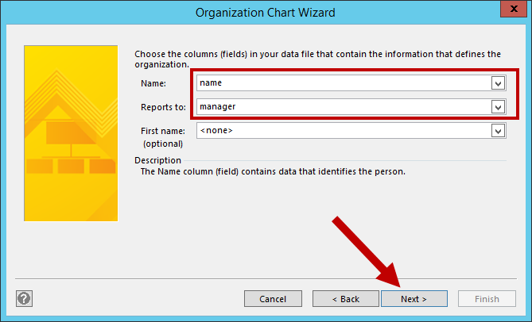

1. Now choose the files you want to display. **Name** and **title** should already appear. Add **department** to the *Display fields* list, reorder the columns if desired and then click **Next**.

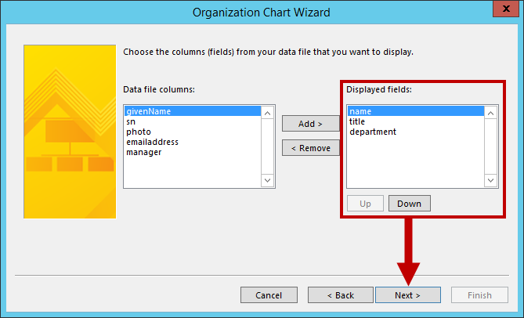

1. The next screen is for setting the columns you want to display on the organizational chart shapes as shape data. Add **emailaddress** to the *Shape Data Fields* and then click **Next**.

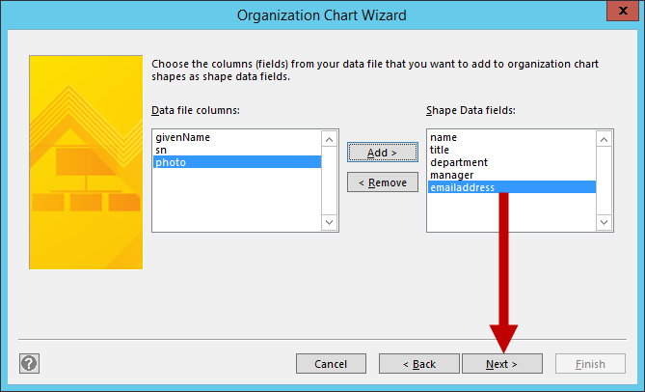

1. Navigate to **C:\Student\Modules\VisioServices\Lab\** then select **ProfilePhotos** and click **Open**.

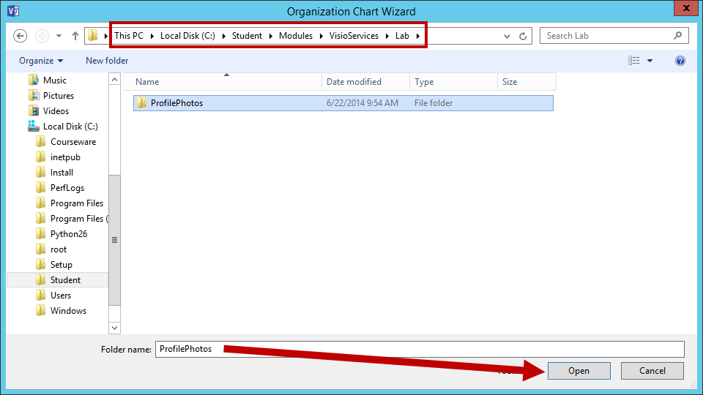

1. In the **Match pictures based on** drop-down list, choose **givenName** and then click **Next**.

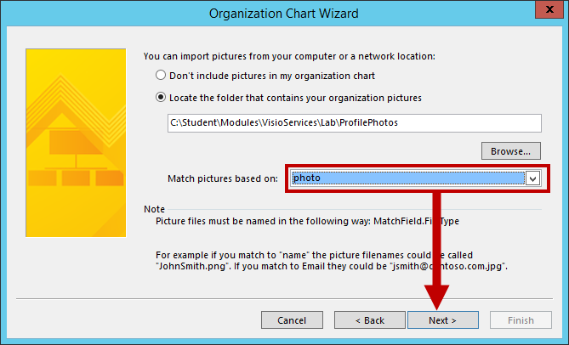

1. In the screen, select **I want to specify how much of my organization to display on each page** and click **Next**.

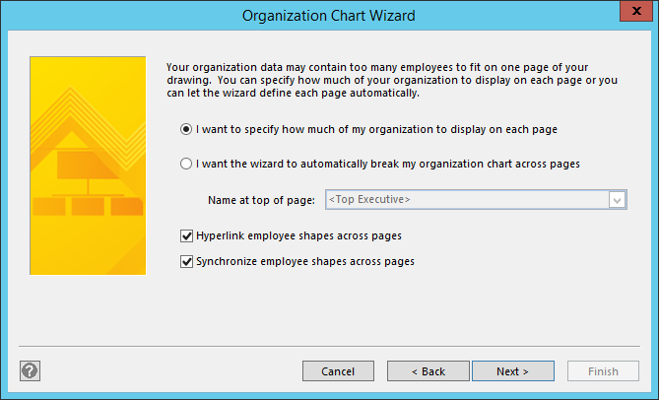

1. From the Pages screen, ensure the **Employee at Top of Page** is set to **Clyde** **Bixby** and the **Additional Levels** is set to **All Subordinates** and then click **Finish**.

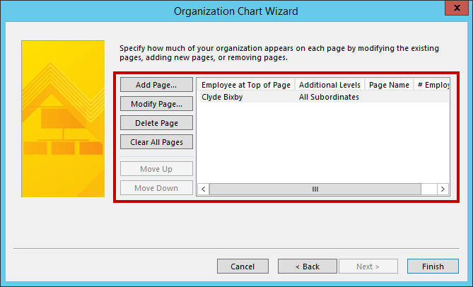

To better organize the charts you can Add, Modify, Delete, or Clear All Pages. Breaking the chart down into pages is helpful when there is a lot of employees being added to the Organizational chart. For example, you may want to break down the pages based on the Departments. To do so you simply click on the Add Page button and then configure the Employee at Top of Page and Additional Levels as well as set the Page Name. Each page will be clickable and display the appropriate view on the screen based on the page (view) that gets selected.

1. The Organizational Chart will now be created and should display similar to the image below.

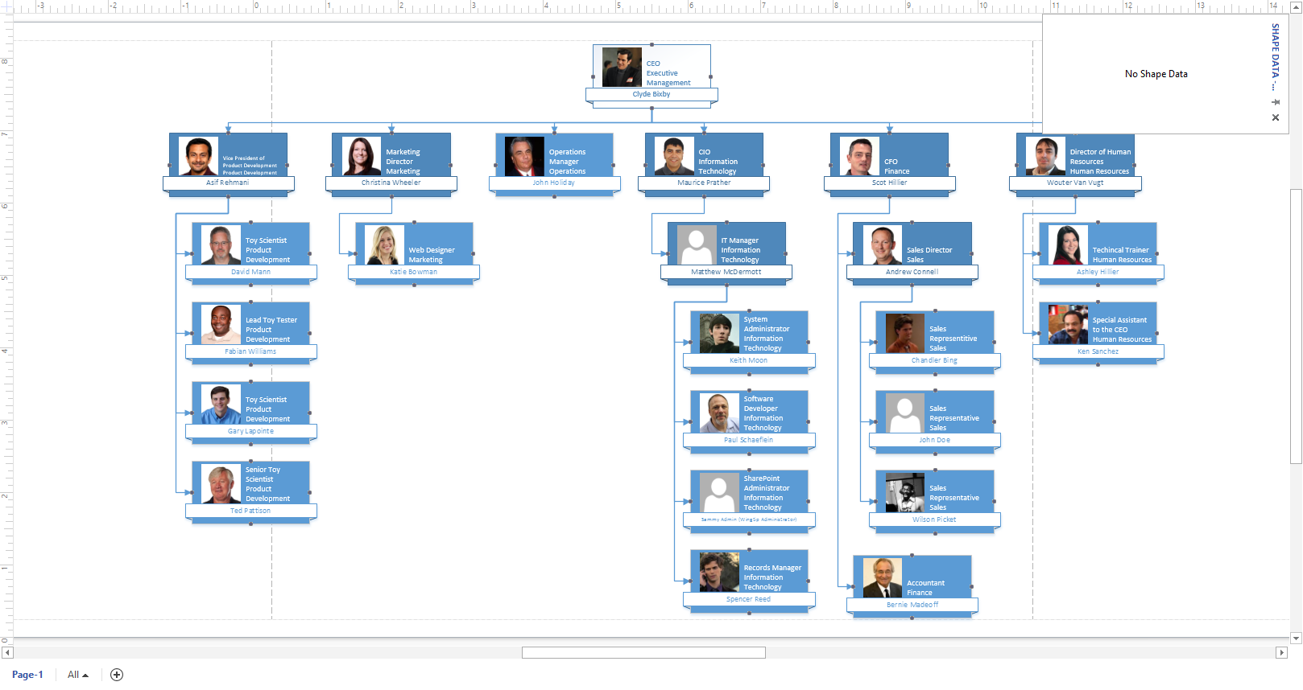

1. Click on one of the shapes such as Ken Sanchez and notice the Shape Data updates with the appropriate information.

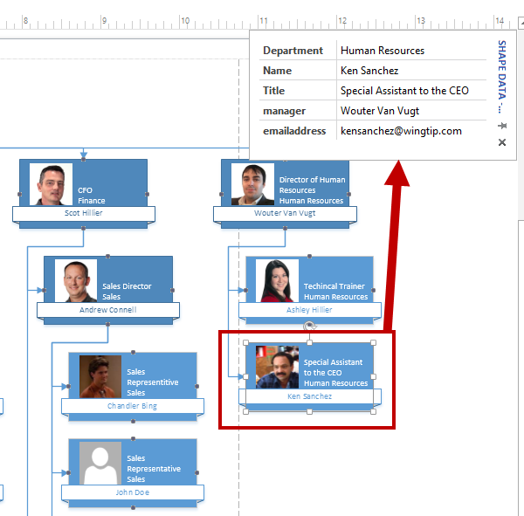

#### Publish the Organizational Chart to SharePoint

1. With the file still open in Visio, click **FILE** and then click **Save**.
2. Click **Computer** and then click **Browse**.
3. **Save** the file locally to **C:\Student\Modules\VisioServices\Lab\** with the file name **OrgChart.vsdx**.

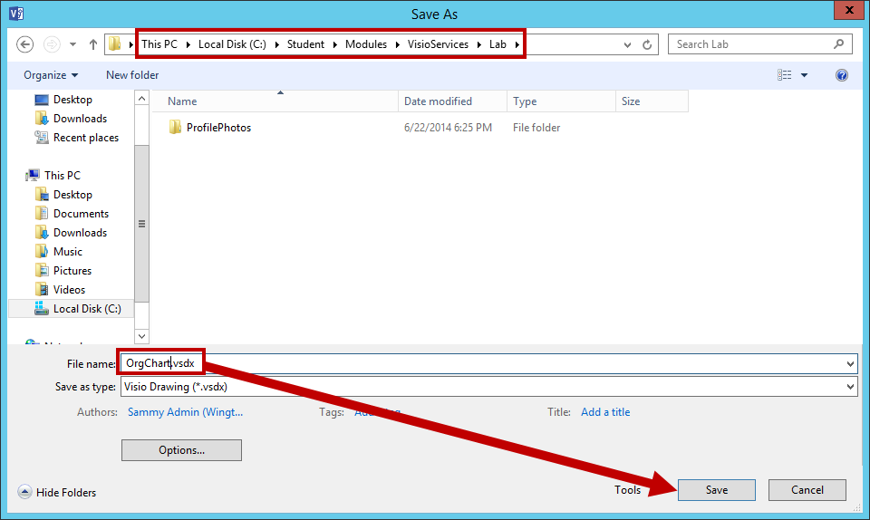

1. Navigate in the browser back to your BI Center site: <http://intranet.wingtip.com/sites/bicenter>
2. Upload the **OrgChart.vsdx** Visio file to the **Documents** library.
   1. Navigate to the Documents library by going to the **Site Contents** and then click on the **Documents** tile.
   2. From the **FILES** tab, click on **Upload** **Document**.

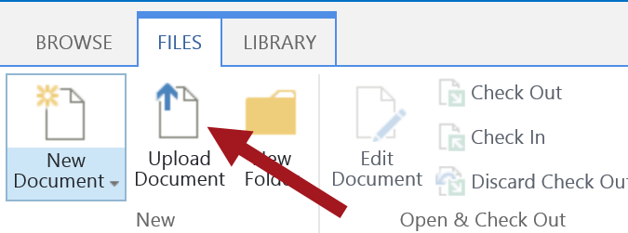

* 1. Browse to your locally saved Visio file **C:\Student\Modules\VisioServices\Lab\OrgChart.vsdx** and then click **Open**.

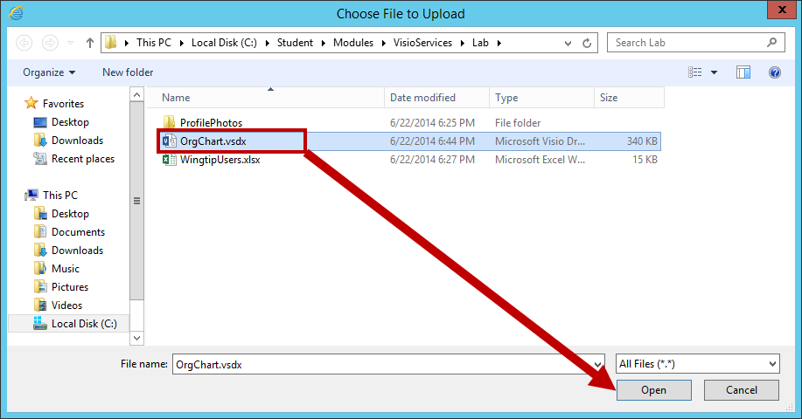

* 1. Then click **OK**.

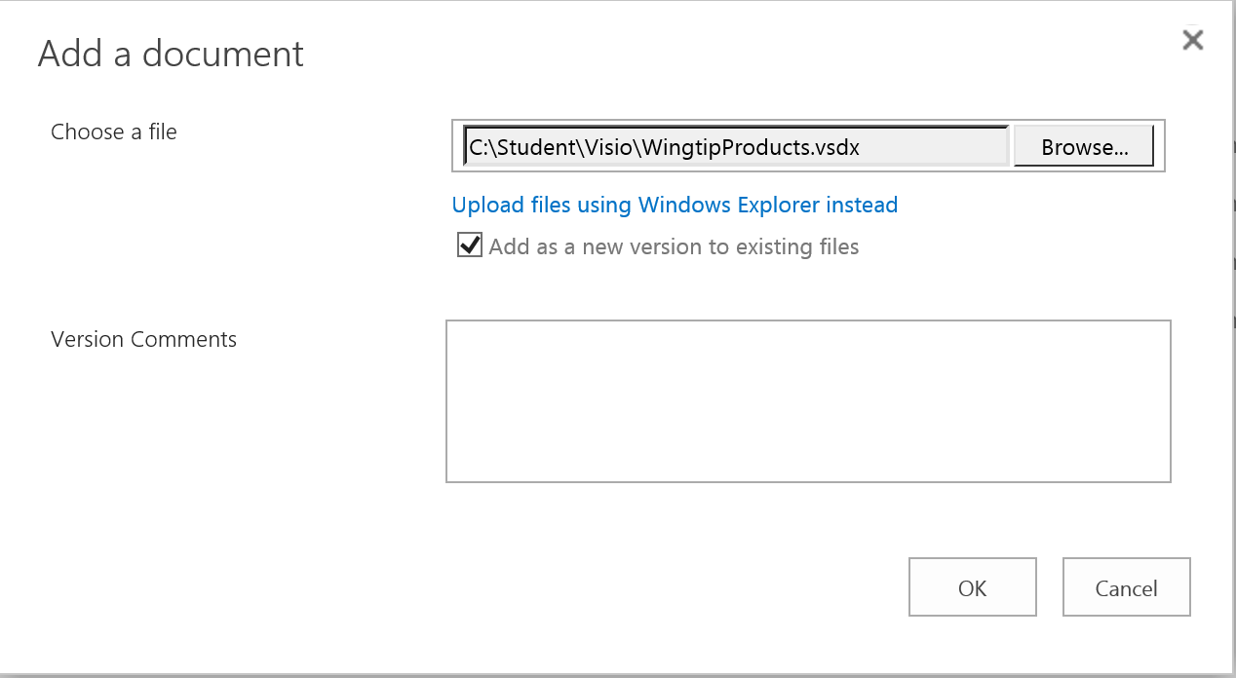

1. Click on the newly uploaded **OrgChart.vsdx** Visio file to view the file in the browser through Visio Services.

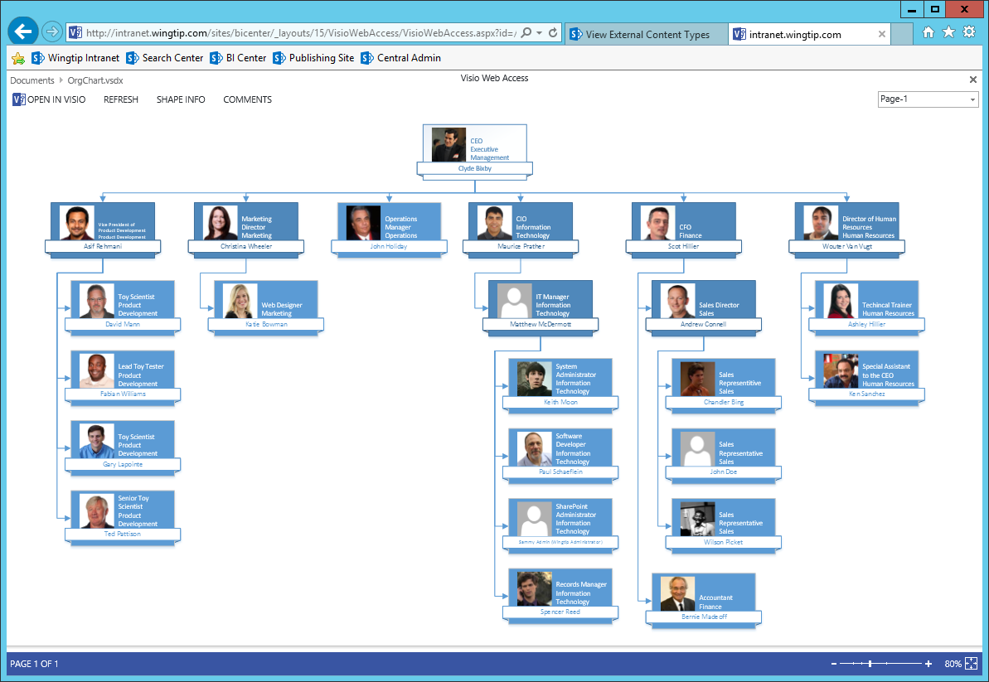

1. Click on the **SHAPE INFO** link located above the Org Chart. Resize the Shape Info box accordingly and then click on a shape for one of the employees and notice the Shape Info data updates accordingly.

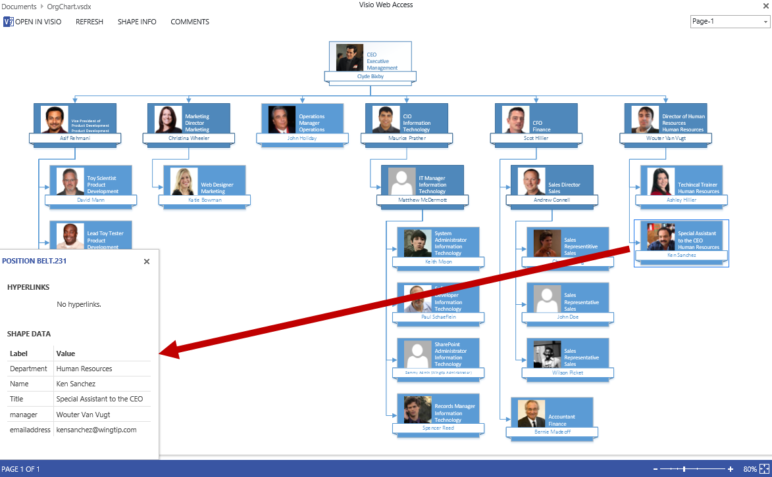

Notice the HYPERLINKS section in the Shape Info box is empty. You can go back and modify the Visio file and update the field with a hyperlink and add/remove fields displayed in the Shape Info dialog or make other changes such as the Shape Design that is being used.

1. If time permits, go back and make changes to your Visio file and then republish and see the changes reflect through Visio Services. Continue to make change as desired and once complete you are finished the lab for this module.